Error Handling

Redis Server not up:

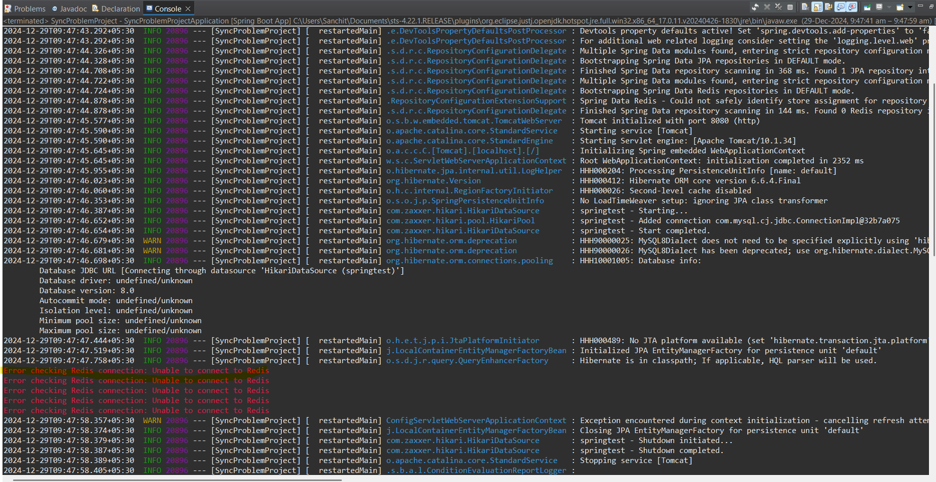

GET api/products/get/{id} // Invalid ID

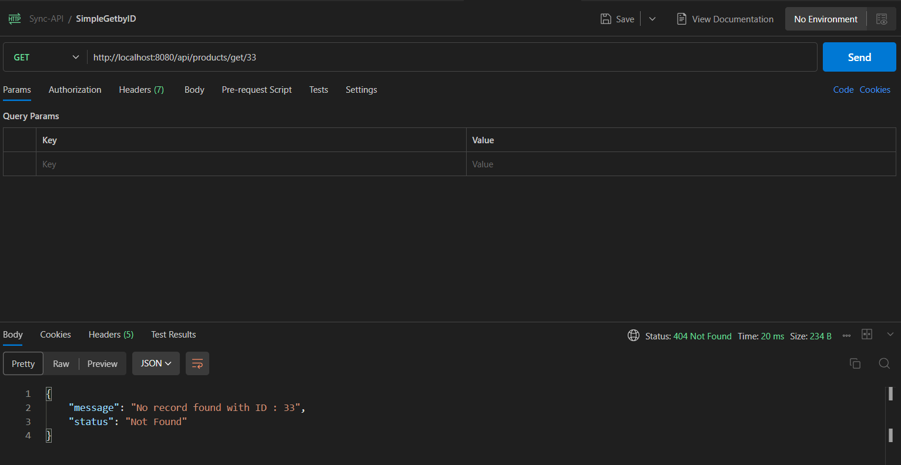

POST api/products/create // put ID which is already present in DB

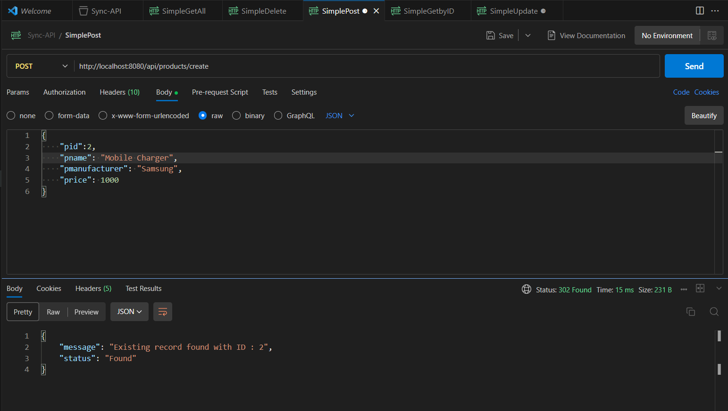

GET /actuator/health

